**Deerwalk Institute Of Technology**

**Database Administration**

**Lab: 3**

**Submitted By: Submitted To:**

**Name: Sagar Giri Narayan Chalise**

**Roll No. 205**

**Date:**

**Configuring the user**

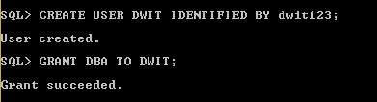

**Data Control Language (DCL)**

It is a language used to control access to data stored in database.

1. **GRANT**

It allows specified users to perform specific tasks.



1. **REVOKE**

It cancels previously granted or denied permissions.



**Transaction Control Language (TCL)**

It is a subset of SQL, used to control transactional processing in a database. A transaction is logical unit of work that comprises one or more SQL statements, usually a group of Data Manipulation Language (DML) statements.

1. **COMMIT**

It is used to apply the transaction by saving the database changes.



1. **ROLLBACK**

It is the process to undo all changes of a transaction.

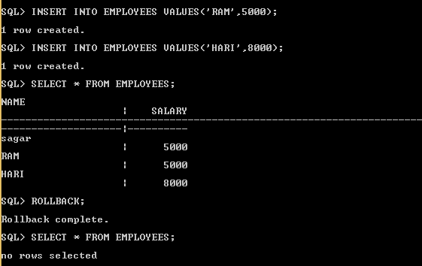

1. **SAVEPOINT**

It is used to divide the transaction into smaller sections. It defines breakpoints for a transaction to allow partial rollbacks.

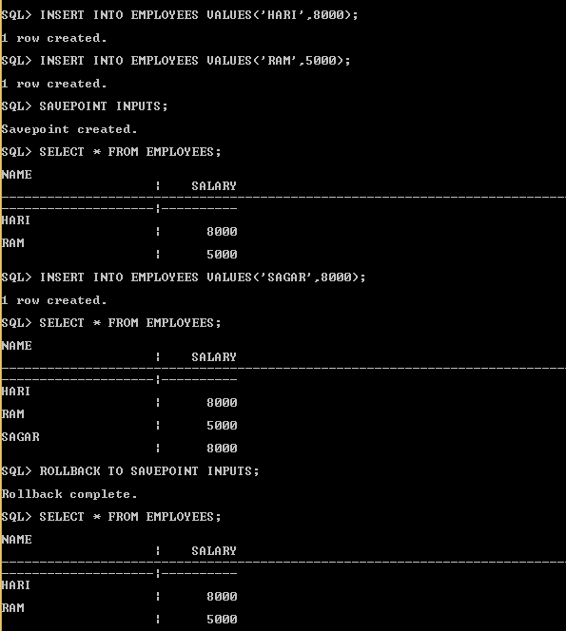

**Data Definition Language (DDL)**

It is a language for defining data structures, especially database schemas.

1. **CREATE** It is used to establish a new database, table, index or stored procedure.

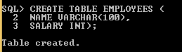

1. **ALTER**

It is used to modify the existing database object.

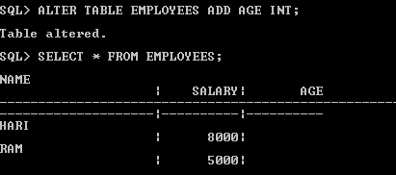

1. **DROP**

It is used to remove a table from database. The table’s entire row, indexes will also be removed. This operation can be rolled back.

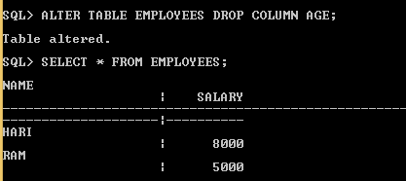

1. **RENAME**

It is used to rename a database table.

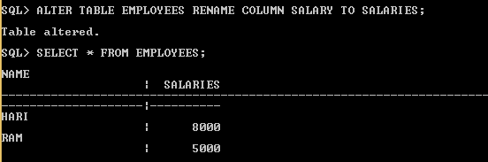

1. **TRUNCATE**

It removes all the rows from a table. The operation cannot be rolled back.

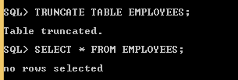

1. **COMMENT**

It is used to make easier to read and maintain.



**DATA MANIPULATION LANGUAGE (DML)**

It is a type of language used for selecting, deleting and updating data in database. It is used to retrieve and manipulate data in relational database.

1. **SELECT**

It returns a result set of records from one or more database tables.

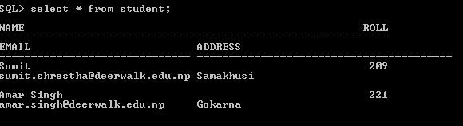

1. **INSERT**

It adds one or more records to any single table in a relational database.

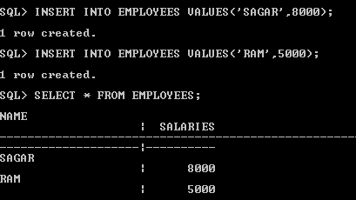

1. **UPDATE**

It changes the data of one or more records in a table.

C:\Users\Dell\Desktop\upodate.PNG

1. **DELETE**

It removes one or more records from a table.

